IW-16
YEAR 9 SCIENCE (MODIFIED)
CHEMICAL SCIENCES
TEST 1 - ATOMIC STRUCTURE, RADIATION

NAME: CLASS: Mark: 

All matter is made of atoms that are composed of protons, neutrons and electrons; natural radioactivity arises from the decay of nuclei in atoms.

Multiple Choice Write the answer to each question in the appropriate box at right.

1. γ, β, α, B

IN ORDER, the above symbols mean:

A Gamma, Beta, Alpha, Boron.
B Gamma, Boron, Alpha, Beta.
C Alpha, Beta, Gamma, Beryllium.
D Alpha, Beryllium, Gamma, Beta.
QUESTION | ANSWER
1
2
3
4
5
6
7
8
9
10
2. The nucleus of which atom is identical to an alpha particle?

A H - Hydrogen
B He - Helium
C Li - Lithium
D Ti - Titanium

3. Which of the following statements about atoms is true?

A An atom is mostly empty space.
B Neutrons and protons are found in the nucleus with the electrons.
C Electrons circle the nucleus all the time.
D The number of neutrons found in the nucleus of an atom is always the same.

4. The mass number of an element is the total number of:

A electrons in an atom.
B protons in an atom.
C protons and electrons in an atom.
D protons and neutrons in an atom.

5. The atomic number of an element is the total number of:

A electrons in an atom.
B protons in an atom.
C protons and electrons in an atom.
D protons and neutrons in an atom.
6. A charged atom is called:

A an isotope.
B an ion.
C a proton.
D radioactive.

7. Beta particles are:

A fast-moving electrons.
B positively charged.
C heavier than an alpha particle.
D unable to penetrate human skin.

8. One of the particles inside the atom is very much lighter than the others. It is the:

A electron.
B neutron.
C nucleus.
D proton.

9. The nucleus of the atom contains:

A only neutrons.
B only protons.
C electrons and neutrons.
D neutrons and protons.

10. Different isotopes of the same element contain different numbers of:

A electrons.
B neutrons.
C protons.
D nuclei.

Short Answer Write the answer to the questions in the spaces provided.

1. Complete the following table.

ELEMENT | PROTONS | NEUTRONS | ELECTRONS
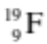
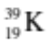

(2)

2. The graph below shows the radioactive decay of iodine-131.

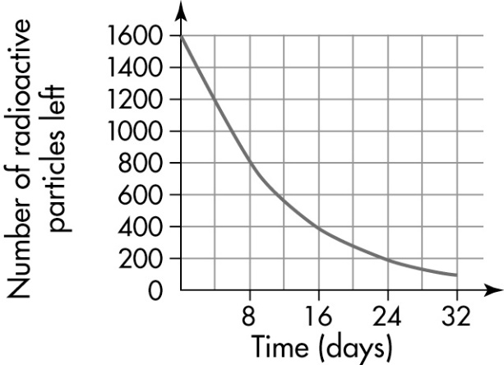

What is the half-life of iodine-131? days
(1)
3. List ONE major long-term effects on humans caused by cell damage resulting from exposure to large amounts of nuclear radiation.

•

(1)

4. Describe ONE uses of nuclear radiation in medicine and/or industry.

•

(1)

